INSTRUCTIONS MANUAL
ELECTRIC HEATING ELEMENT FOR TOWEL RAILS

INDEX

- General information 3
- Safety Instructions… 4-5
- Intended use of device 5
- Technical information 5
- Installation of the heating element… 6-18
- Model Descriptions 19-25
- Product Disposal 25
- Warranty & Warranty Certificate 26

- GENERAL INFORMATION
NAME OF THE MANUFACTURER: REINA DESIGN RADIATOR
ADDRESS : Unit 6, Weybridge Farm Stanbourne Road Great Yeldham C09 4RB ENGLAND
http://www.reinadesign.co.uk/
e-mail: info@atayglobal.com

FOREWORD
The purpose of this document is to provide important information, regarding the installation and use of this appliance.
To obtain the best possible performance and trouble free operation from your appliance it is very important to carefully read these instructions.
The manufacturer declines all responsibility for any operations effected on the appliance without respecting the instructions reported in this manual.

- SAFETY INSTRUCTIONS
Please read the below instructions thoroughly and study the images carefully. 1.Never use the device that is damaged in any way.
2-Always connect the device to the grounded installation (socket with earth pin). 3-Do not install the heater under an electrical socket point.
- Your electric heater should be filled with a carefully measured amount of liquid. In any case which demands its supplementation contact your supplier.
- The heating element is intended to work in a liquid agent environment. It is advised not to turn the device on in dry conditions for longer than 5 seconds.
- Electric heater is not a toy. Children under the age of 3 should not be allowed within close proximity of the device without the supervision of an adult.
- Children should be supervised to ensure that they do not play with the appliance.
- Children aged 3 to 8 should only be allowed to operate the heater when it has been properly installed and connected. The child must be under adult supervision or have been trained to safely operate the device while understanding the risks.
- Do not touch metal parts – burning risk. Always make sure that the wire does not touch the heating element that is hot.
- If the device is used to as a clothes and towel dryer, ensure that the fabrics drying on it have only been washed in water, avoiding contact with with any harsh chemicals.
- To ensure the safety of very small children, install the towel rail so that the lowest tube is at least 60 cm above the floor.
- The device should only be installed by a qualified installer in accordance with the applicable regulations regarding safety and all other regulations.
- All installations to which the device is connected should comply with regulations applicable in the country of installation and use.
- Extension leads or electric plug adapters should not be used in order to supply power to the heater.
- The electric installation to which the heater is connected should have the right current differential and overcurrent relay (R.C.D.) OF 30 mA
- An omni-pole cut-out is required for disconnecting the device on all poles ,via joints positioned at least 3 mm apart.
- Please check regularly if the power wire is not damaged and if the device can be used in a safe manner.
- The device must not be connected while being installed. Unplug the device or disconnect the power wire from electrical circuit. Put the casing on the body of the heating element unit before plugging the device. It is necessary to secure the control panel with the right tool in order for the device to work as required
- Do not open the casing.
- The device is intended for home use only.

- This appliance is not intended for use by persons ( including children ) with reduced physical, sensory or mental capabilities or lack of experience and knowledge , unless they have been given supervision or instruction concerning use of the appliance by a person responsible for their safety.
- This appliance can be used by children aged from 8 years and above and persons with reduced physical, sensory or mental capabilities or lack of experience and knowledge if they have been given supervision or instruction concerning use of the appliance in a safe way and understand the hazards involved. Children shall not play with the appliance. Cleaning and user maintenance shall not be made by children without supervision.
- If the supply cord is damaged, it must be replaced by the manufacturer, its service agent or similarly qualified persons in order to avoid a hazard.
- Before installing or removing the device, make sure it is disconnected from the power source.
- Do not open the device-any interference with internal components will invalidate the warranty.
- Regularly check the device for damage to ensure it works and safe to use.
- The device must be disconnected from the mains during cleaning and maintenance.

- INTENDED USE OF DEVICE
Reina heating elements and control units are electric heating devices and are intended for installation and use in towel rails used for drying towels or clothes.
They are not intended for room heating.
Heating elements are intended to operate in closed installation (not open to atmosphere) only.

TECHNICAL INFORMATION

Electric supply | 230/ 50 Hz
Heating output  available | 150, 200, 250,300, 400,500, 600, 700, 750,  800, 900
Device protection  class | Class I & Class II
Towelrail connection | G 1/2"
Casing protection mark | IP44
Certification | These products are in compliance with 2014/30/EU Electromagnetic Compatibility Directive and 2014/35/EU Low Voltage Directive  These products carry CE mark accordingly.

4-INSTALLATION OF HEATING ELEMENT

Installation for these models ;
  - Standard Electric Element (ELM/S)
  - Mini Round Thermostatic Control Unit (ELMMRN)
  - Weekly Thermostatic Control Unit (ELMWKY)

WARNING! The device must not be connected to electricity during installation. unplug the device prior to installation.
WARNING! Please take every precaution when filling the towel rail in order to avoid being burnt by hot liquid
WARNING! Do not switch the heating element on if it is not fully immersed in the towel rail. WARNING!
Do not install the heating element by turning the enclosure itself! Tightening of the unit should be made by the help of wrench!
WARNING! Remove the protective coating on the plastic enclosure before use!
WARNING! For IP44 Protection the heating element assembly must be made together with the special gasket given inside the package.
WARNING! Protective earthing conductor (yellow & green wire) of control unit should be connected to earthing wire of the heating element .This connection is necessary secure the earthing continuity.
WARNING! The device should only be installed by a qualified installer in accordance with the applicable regulations regarding safety and all other regulations.
WARNING ! The towel rail is to be installed so that switches and other controls can not be touched by a person in the bath or shower.
WARNING! Heating element should not be fitted horizontally or turned downwards.
WARNING! Connect the cables coming from the control unit following below instructions:
WARNING ! Filling the towel rail with too much liquid leads to exceeding of acceptable pressure and damaging of the towel rail or heating element.
WARNING ! Water, water with anti-freezing agent should be used as a heating agent – possibility of installation and correct use is conditioned by meeting manufacturer’s requirements on the towel rail and heating element.
- Brown wire — connection to live circuit (L) of the heating element
- Blue wire — connection to neutral circuit (N) of the heating element
- Yellow & green wire — connection to earth (PE) of the heating element.
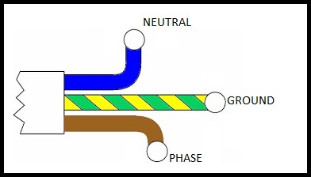

  - The resistance will be placed inside the towel rail.

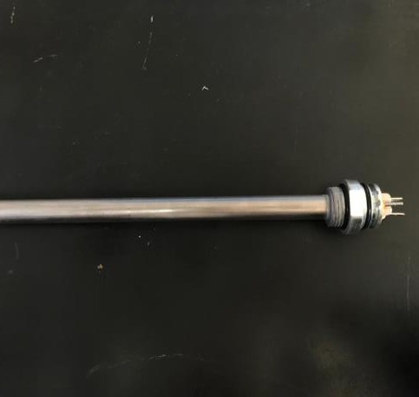
Faston Element - Standard

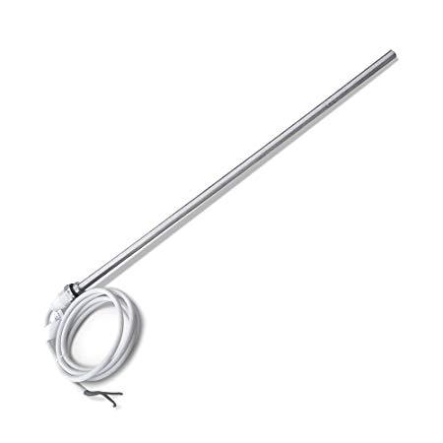
Standard Electric Element

b)
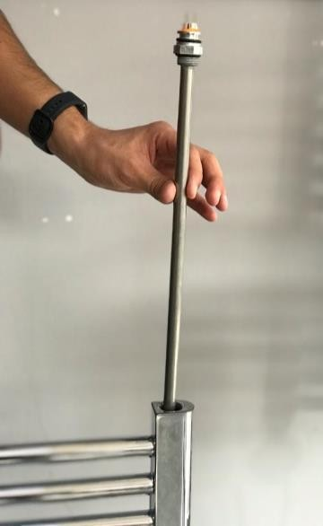
Towel rail.

  - The resistance part shown in the figure is fixed to the towel warmer by using the 26 numbered key.
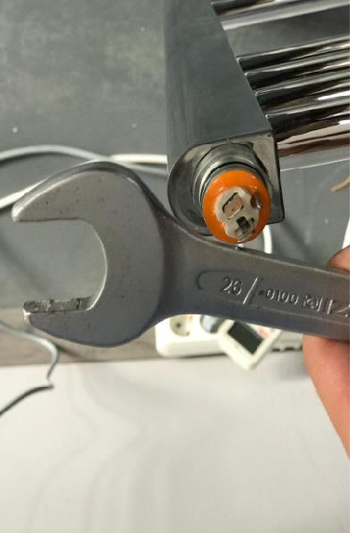
a)
Heating element.

Key number 26.

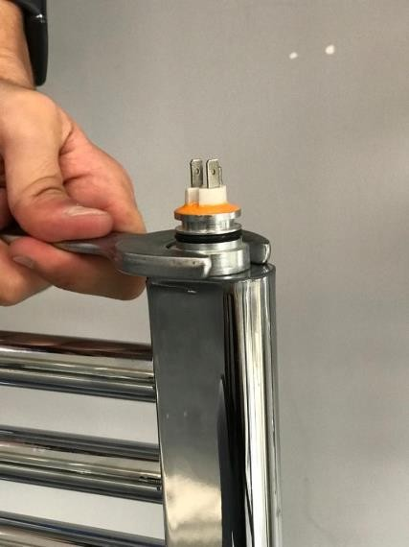
b)
In this figure is fixed to the towel warmer by using the key number 26.

  - Tilt the towel rail to ensure that the top collector opening is at its highest point.
  - Before filling the radiator with heating fluid, make sure that the "radiator - heater" connection is tight.
  - Position the controller so that it faces you or to the side.
  - The towel warmer should never rest on the heating element controller or any part of its connection!
  - Tilt the towel and fill the towel with warming agent.

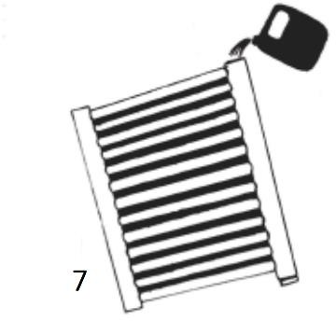

  - Return the towel to the upright position and check the level of the liquid inside
.
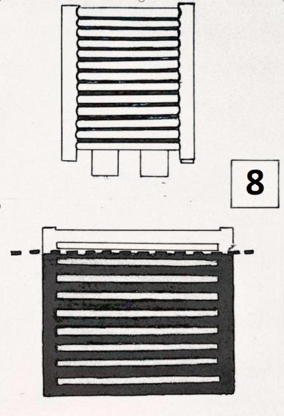

  - When the towel rail is in an upright position, it is connected to the control unit.
  - The connection between the control unit and the terminals of the resistor is made. The following steps are applied in order;

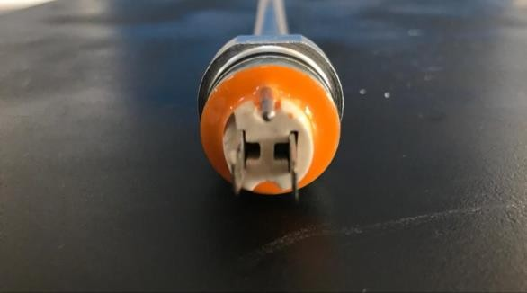
1
1:Ground terminal
2: Power
terminals
Figure1
2

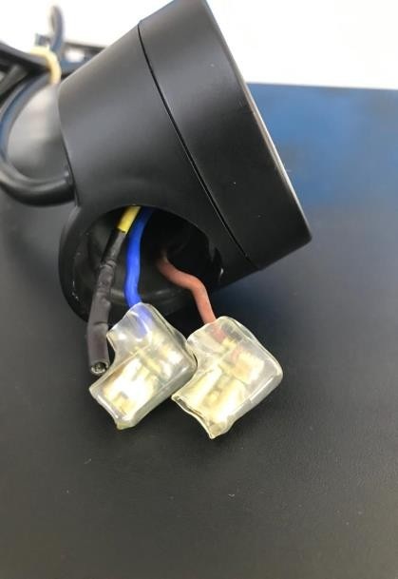

3: Ground wire

4:Power wires

Figure2
3
4

Connecting the grounding terminal number 1 in Figure 1 and the grounding cable number 3 in Figure 2 connections are made.

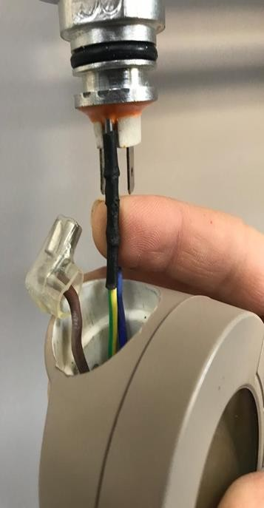

i)

In Figure 2, power cables number 4 are connected to power terminals number 2 in Figure 1, regardless of the cable color.

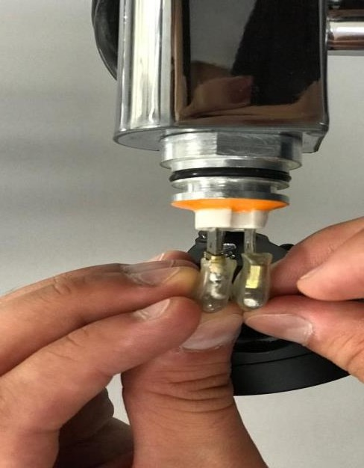
ii)

  - The screw on the back of the control unit is fixed with the help of a screwdriver.
WARNING! !After making sure that the screw is fully seated in the hole on the back of the controller, tighten it all the way.

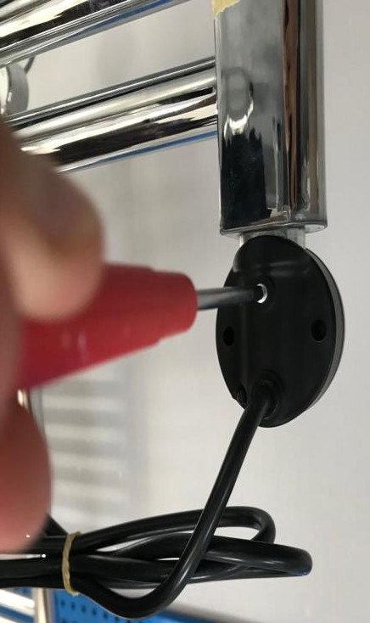
Screw slot
Screwdriver.

  - Make sure the connection between the towel warmer and the heating element is tight.
  - Position the controller for easy and convenient access.
  - To connect the device to the mains, the cable colors shown in the figures must be taken into account. When connecting the control unit to the mains, phase, neutral and earth connections must be made carefully

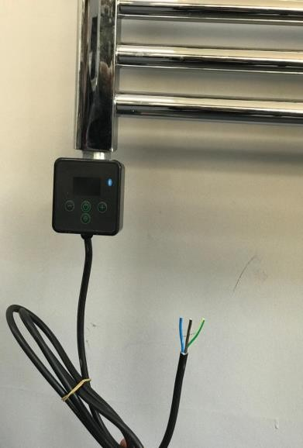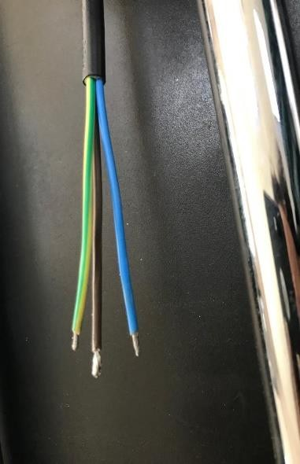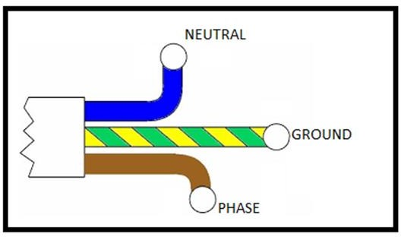

WARNING! You have must to check the position before start the device. The towel rail must be verticonal positon.
  - Connect the heating element unit to the outlet / plumbing. The device is ready for operation.
  - Set the maximum possible temperature and observe the liquid level rise, excess liquid may overflow from the upper cavity. Clean up excess fluid to prevent the controller from flooding or getting wet.
  - When the heating element level stops rising, wait 5 minutes, turn off the heating element unit and turn off the power to the appliance.
  - Do not wait until the towelette has cooled down and pour a small amount of liquid into the middle of the upper tube.
  - Close the upper opening of the collector with a special gasket and put it back on the wall.
Installation for On Off Touch Element (ELMOOT)

- The product is placed inside the towel rail.
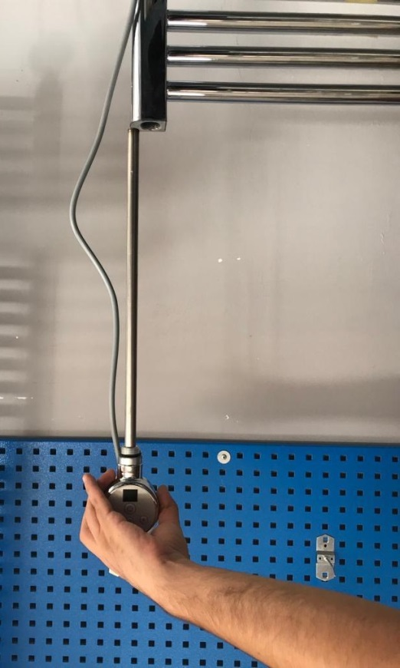

- Since the control box comes pre-assembled with a resistor, at this stage we fix the resistor to the towel warmer. The part of the resistance shown in the figure is fixed to the towel warmer by using the key number 26.

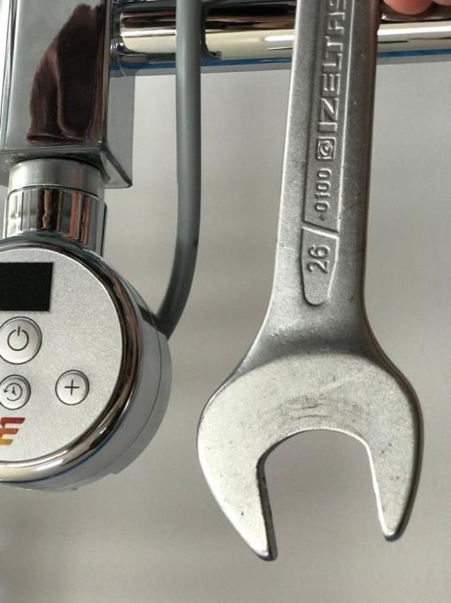
Key number 26.
i)
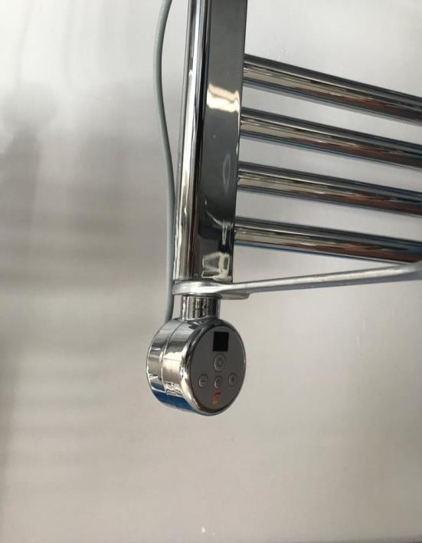
ii)
Fix to the towel rail

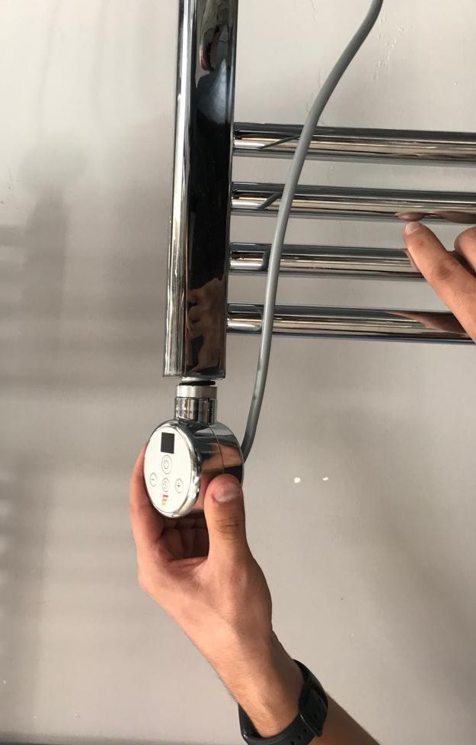
After the resistance is fixed well, it has a tolerance of up to 60°(degrees) and can be corrected manually.

iii)

- Tilt the towel rail to ensure that the top collector opening is at its highest point.
- Before filling the radiator with heating fluid, make sure that the "radiator - heater" connection is tight.
- Position the controller so that it faces you or to the side.
- The towel warmer should never rest on the heating element controller or any part of its connection!
- Tilt the towel and fill the towel with warming agent.
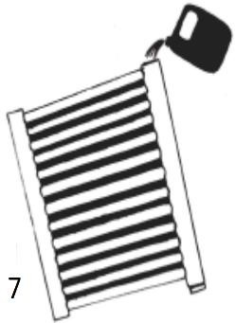

- Return the towel to the upright position and check the level of the liquid inside.

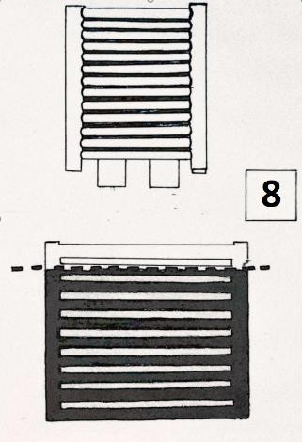
- Make sure the connection between the towel warmer and the heating element is tight.
- Position the controller for easy and convenient access.

- To connect the device to the mains, the cable colors shown in the figures must be taken into account. When connecting the control unit to the mains, phase, neutral and earth connections must be made carefully.

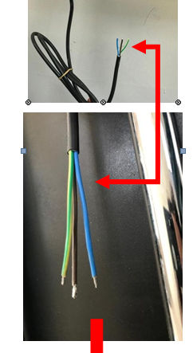

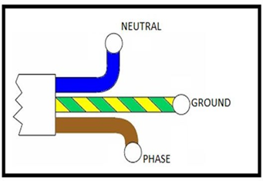
WARNING! You have must to check the position before start the device. The towel rail must be verticonal positon.
- Connect the heating element unit to the outlet / plumbing. The device is ready for operation.
- Set the maximum possible temperature and observe the liquid level rise, excess liquid may overflow from the upper cavity. Clean up excess fluid to prevent the controller from flooding or getting wet.
- When the heating element level stops rising, wait 5 minutes, turn off the heating element unit and turn off the power of the appliance.
- Do not wait until the towel rail has cooled down and pour a small amount of liquid into the middle of the upper tube.
- Close the upper opening of the collector with a special gasket and put it back on the wall.

5-MODELS DESCRIPTIONS

Weekly Thermostatic Control Unit model is controlled by 4 buttons.
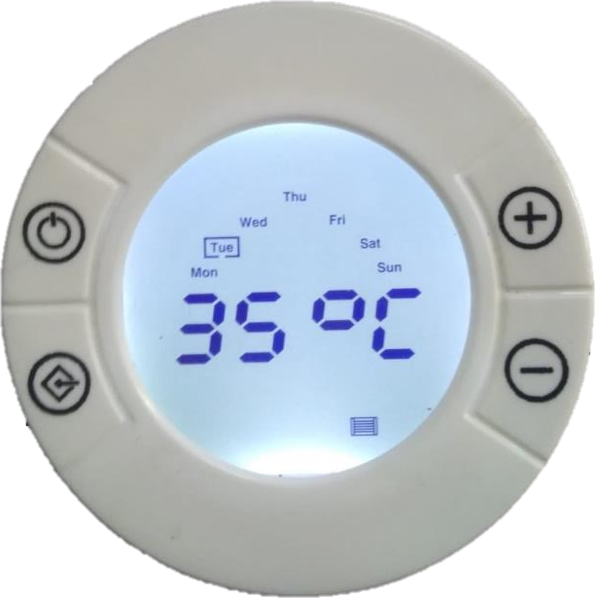
Stand by / enter
Up

Down
Menu

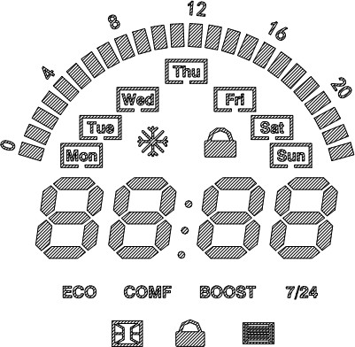
When the device is energized for the first time (plugged in), the device starts on the main screen (in manual mode).
When the buttons are pressed to reach the functions, the lighting is turned on. After a while (30sec), the backlight is turned off to save power.

FUNCTIONS:

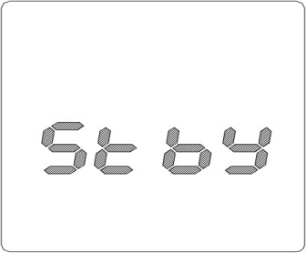
STAND BY MODE
By pressing the Standby / Enter button, the product switches to stand-by mode. When the product is in stand-by mode, if Standby / Enter buttons are pressed again, you can exit stand- by mode.
In stand-by mode, only ‘stby’ is displayed on the screen.

RESISTANCE OPERATION ICON
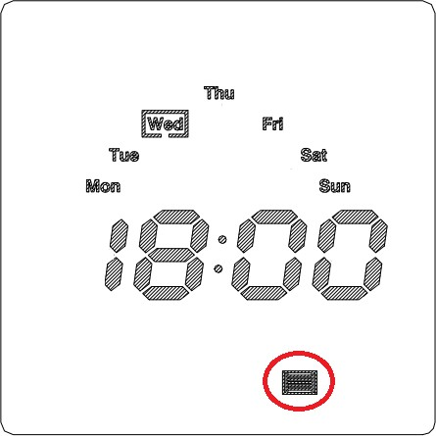

If the set temperature is higher than the water temperature, the resistance connected to the product gets hot. If the set temperature is lower than the water temperature, the resistance connected to the product will not heat up. While the resistance is being heated, the resistance symbol on the screen is lit.
The measured temperature value is not displayed on the screen.

TIME ADJUSTMENT

If desired, time adjustment can be made. With pressing standby / enter and up button together, time adjustment made. When entered to time adjustment mode, the second 2 seven segments flash, prompting the user to set the minutes. The user sets the minute with the up and down buttons and confirms by pressing the Standby / Enter button.
Next step is hour adjustment. The first 2 seven segments flash, prompting the user to set the clock. The user sets the time with the up and down buttons and confirms by pressing the
Standby / Enter button.

Then it comes to the day setting section. The user chooses the day using up and down buttons. The user confirms by pressing the Standby / Enter button. After selecting the minute, hour and day, the user presses the menu button to exit the setting.
MENU TRANSITIONS

When the device is on, the user can switch between the menus by pressing the menu button. Menu transitions are performed in the following order.
ECO -> COMFORT -> BOOST -> 7/24
MANUAL MODE
Manual mode is active when the user is in the main menu. By using up and down buttons, the
set temperature value (10-35 degrees) can be adjusted.
If up or down button is pressed for a long time, the set temperature value will increase or decrease rapidly.The set temperature value and time are displayed on the screen in sequence (one after the other)
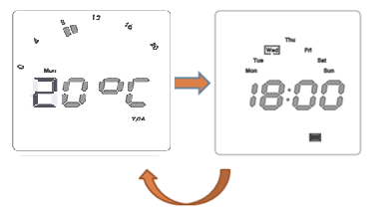

ECO MODE

By pressing the menu button once ECO mode can be selected. 'ECO' icon flashes on the screen. In this mode, the set temperature value of the device is set to 20 degrees. The set temperature value and time are displayed on the screen in sequence (one after the other).

Since this mode is set 20 degrees, the up and down keys are nonfunctional for this mode.

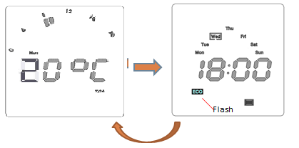
COMFORT MODE

If the user presses the menu button twice while in the main menu, comfort mode is selected.
When the mode is selected, the 'COMF' icon flashes on the screen. In this mode, the set
temperature value of the device is set to 25 degrees. The set temperature value and time are displayed on the screen in sequence (one after the other)

Since this mode is set 25 degrees, the up and down keys are nonfunctional for this mode.

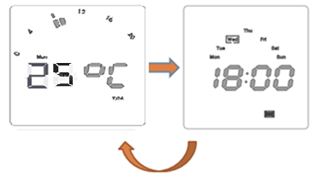

BOOST MODE

If the user presses the menu button three times, the boost mode is selected. When the mode is entered, the 'BOOST' icon lights up on the screen. In this mode, the set temperature value of the device is fixed at 35 and can be adjusted from half hour to 8 hours for the selected time. The duration can be adjusted starting from 30 minutes up to 8 hours, with the up and down buttons.

The time flashes and the user's approval is awaited. The user confirms the time with the standby / enter button. Afterwards, the BOOST icon will flash for the selected time. And countdown is made from the selected time on the screen.

When boost mode is selected, standby button is used as enter button to make time setting . After the mode is set the button can be used for standby function.

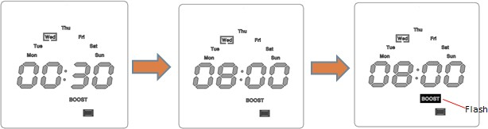

OPEN WINDOW

When there is a sudden temperature drop in the device (15 degrees in 20 minutes), the temperature of the resistance connected to the towel warmer is cut off.
The open window icon is displayed on the screen.

WEEKLY TIMER (7/24) PROGRAMMING

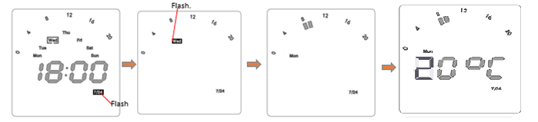

If the user presses the menu button four times, the weekly program mode is reached. '7/24' icon flashes on the screen, press standby / enter button to select the mode.
The '7/24' icon is illuminated on the screen. Day adjustment:
The current day of the week flashes on the display. The desired day can be reached with the up or down buttons. The day to be adjusted is selected by pressing the standby / enter button.

Hour adjustment for selected days:

Hour adjustment can be made from 00:00 to 23:00 at one hour intervals. The desired hour can be reached with the up or down buttons. As many hours as desired can be selected in the program. The desired time is selected by pressing the menu button. After the selection is
made, the boxes representing that hour are lit at the top of the screen.

In addition, the program can be removed by highlighting it with the up or down buttons and pressing the menu button.
After the desired hours of the day selected in the weekly program are programmed, confirmation is given by pressing the standby / enter button.
Temperature adjustment :

The temperature setting should be made for the selected day. The desired temperature can be selected with the up or down buttons. Press the menu button to confirm. Then press the mode button once to exit the weekly program. In this way, a weekly schedule can be set for 7 days of the week.
CHLID LOCK

Child lock mode is selected by long pressing the up and down buttons. When the mode is selected, the lock icon symbol lits. In this mode, the buttons are disabled. Again, long press the up and down buttons to exit the child lock mode.

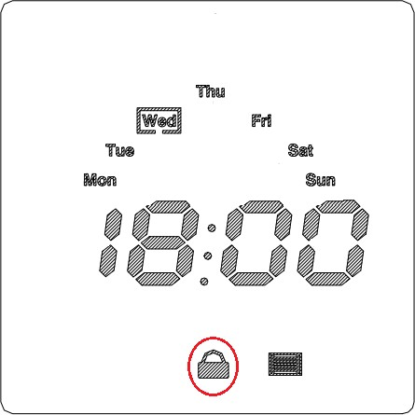

ANTIFREEZE

This mode provides protection against the effects of cold. The device operates at 7 °C. When
the temperature is below 7°C antifreeze mode becomes active and ice symbol is displayed on the screen.

FAILURE MODE

In case of thermostat failure below warning flashes on the screen:

On Off Touch Element (ELMOOT)

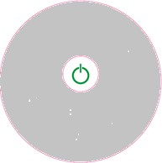
Heating element unit heats the towel rail that it is installed in.
Button is used to turn the device on / off. Green led will illuminate when the device is turned on. The light will go off when the device is turned off.

C ) Mini Round Thermostatic Control Unit (ELMMRN)

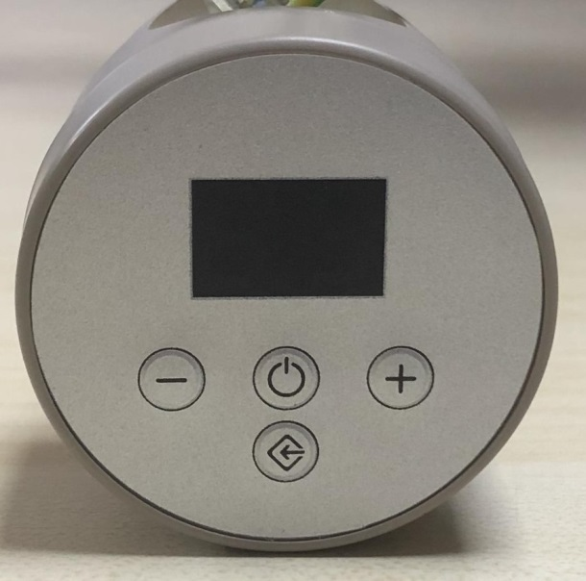

Heating element unit heats the towel rail that it is installed in.
Button is used to turn the device on / off. Buttons and are used to regulate temperature.
The values can be seen on the digital screen.
Button is used to set the time period from 1 to 5 hours.(H1 ,H2,H3, H4, H5 will be displayed
on the screen)
When the timer is set ,(from 1 hour to 5 hours) a flashing dot will appear on the display between the
two numbers . It shows that the timer is working. To cancel timer select zero (H0).

NOTE – If you set the temperature of the control unit lower than the room temperature, the unit will
not operate. The control unit operates when the temperature is set at least 1 degree higher than the room
temperature.

D- STANDARD ELECTRIC ELEMENT

This heating element is single heat (one fixed temperature) controller.

1: heating element
2:power supply cord

6-PRODUCT DISPOSAL

This product should not be disposed of as a general waste but should be brought to the appropriate collection point for re-cycling of electric and electronic devices.
This information is provided by the sign on the product ,user manual and packaging. Information on the appropriate point for used devices can be provided by your local authority
,product distributor or the from where the product was purchased .

7-WARRANTY

- The subject of this warranty is a Reina electric heating element with control unit. Product name and characteristics are specified on the packaging.

- By accepting the device on purchase, the Client confirms that the product is of full value. The Client should immediately inform the Seller of any discovered faults – otherwise it will be understood that the Product was faultless at the time of purchase. This refers especially to any faults or damages of the control panel case.

- Warranty period for the Product is 24 months from the date of purchase

- Any claims made will be processed on production of the warranty card and the evidence of purchase. Manufacturer has the right to reject any claim on the grounds of not presenting of any of the above documents.

- This warranty does not comprise any faults that are due to:

  - incorrect (not in accordance with the manual) installation, use or disassembly,
  - incorrect use of the heating element (ie. for any purpose that is not specified by the Manufacturer as intended for this type of product),
  - Product being handled by unauthorized persons,
–Any faults or damages caused by the Client after having purchased and accepted the Product.

- Should the repair turn out impossible, Manufacturer is obliged to replace the faulty Product with a new, full-value unit of identical parameters.

8-WARRANTY CERTIFICATE
MANUFACTURER:  Name: Reina Design Radiator  Address: Unit 6, Weybridge Farm Stanbourne Road Great Yeldham C09 4RB ENGLAND  e-mail: info@atayglobal.com  Authorised signature:  Stamp: | SELLER:  Name:  Address:  Phone:  e-mail:  Authorised signature:  Stamp:
Type : Electric Heating Element Brand name: Reina  Model: | Warrant Period: 2 Years Repair Period :20 Days  Banderole and Serial No:

